Falling Ball Application Guide

December 2018

Version 0.1

Document Revisions

|  |  |  |
| --- | --- | --- |
| Date | Version Number | Document Changes |
| 12/03/2018 | 0.1 | Initial Draft |
|  |  |  |
|  |  |  |
|  |  |  |
|  |  |  |
|  |  |  |
|  |  |  |
|  |  |  |
|  |  |  |

TABLE OF CONTENTS

1 INTRODUCTION 1

1.1 Scope and Purpose 1

1.2 Process Overview 1

2 HOW TO PLAY 2

3 TO END GAME 3

# INTRODUCTION

## Scope and Purpose

This application allows the user to play the falling ball game. The user earns points by ensuring the ball stays on the horizontal bars without touching the top or bottom of the screen. The game ends when the ball hits the top or bottom of the screen.

This guide will go more in-depth in explaining how the application functions during the game. It is advised that the user already have an understanding of how the falling ball works as a game, but it is not necessarily required.

## Process Overview

Upon launching the game, the game begins with the horizontal bars moving upward and the ball being stationary until being controlled with the arrow keys on the keyboard. Only two arrow keys are required to control the ball: the left and right arrow keys. The left arrow key moves the ball towards the left and the right arrow key moves the ball towards the right, along the horizontal bars or in free space. The game ends when the ball hits the top or bottom of the screen.

# HOW TO PLAY

In order to use the application for its purpose, a game must first be started by the user.

1. Open the application
2. Move the ball left or right with the left and right arrow keys to move between the moving horizontal bars and to avoid hitting the top and bottom of the screen

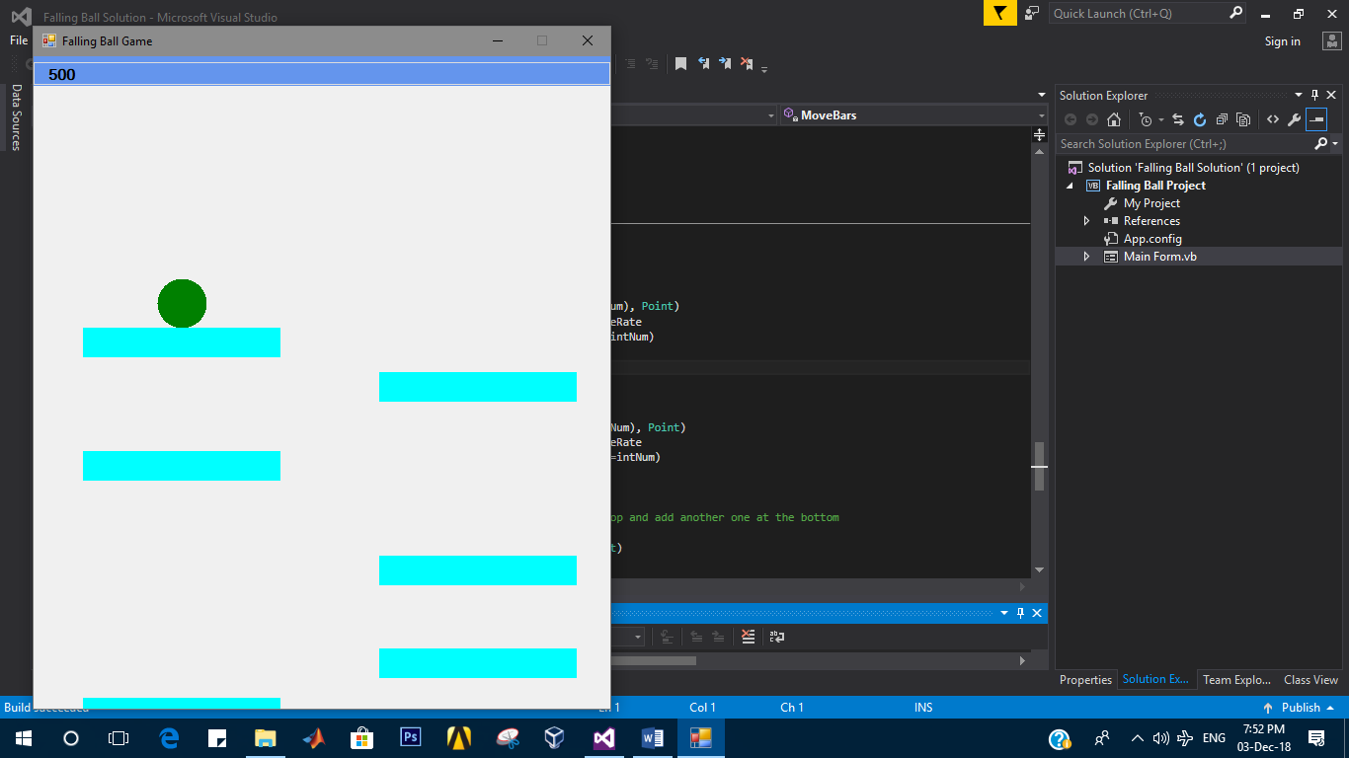

1. Avoid the top and bottom of the screen as long as possible to earn more points

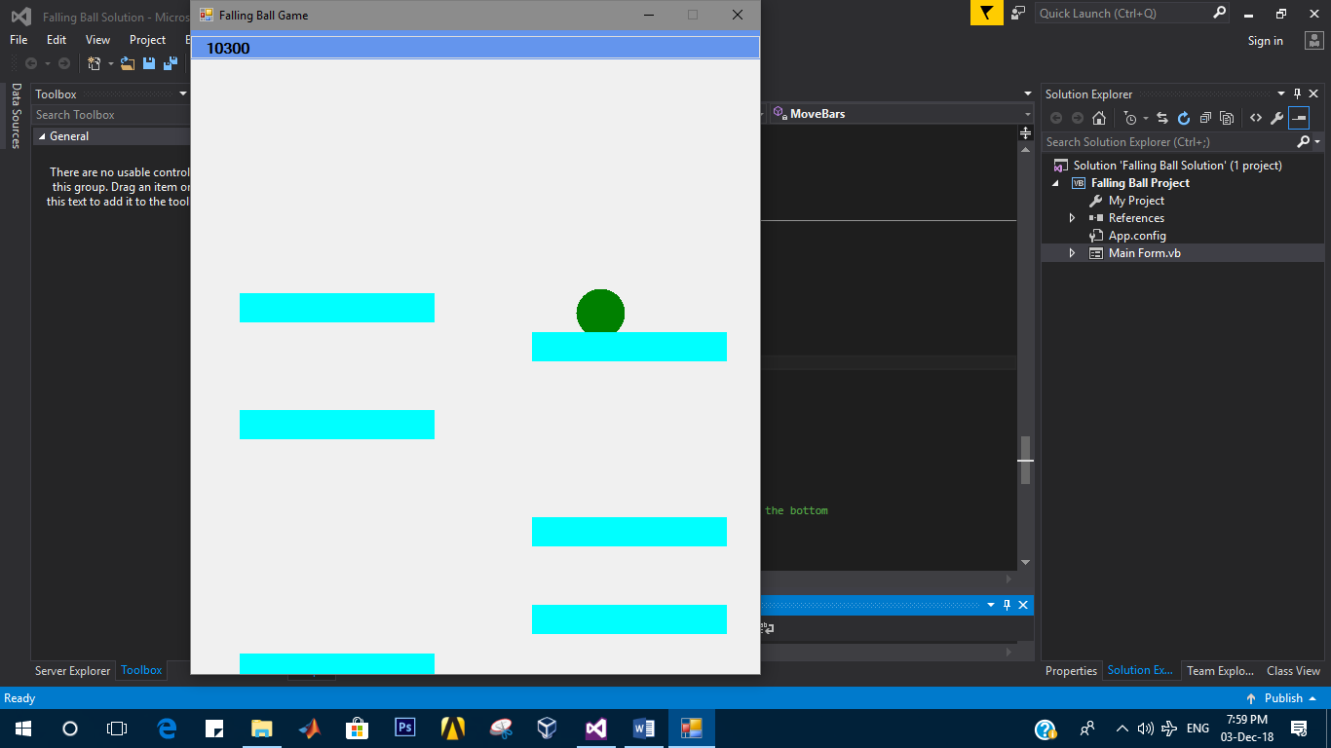

# TO END GAME

There are three ways to end the game:

1. Hit the top of the screen with the ball and then click OK

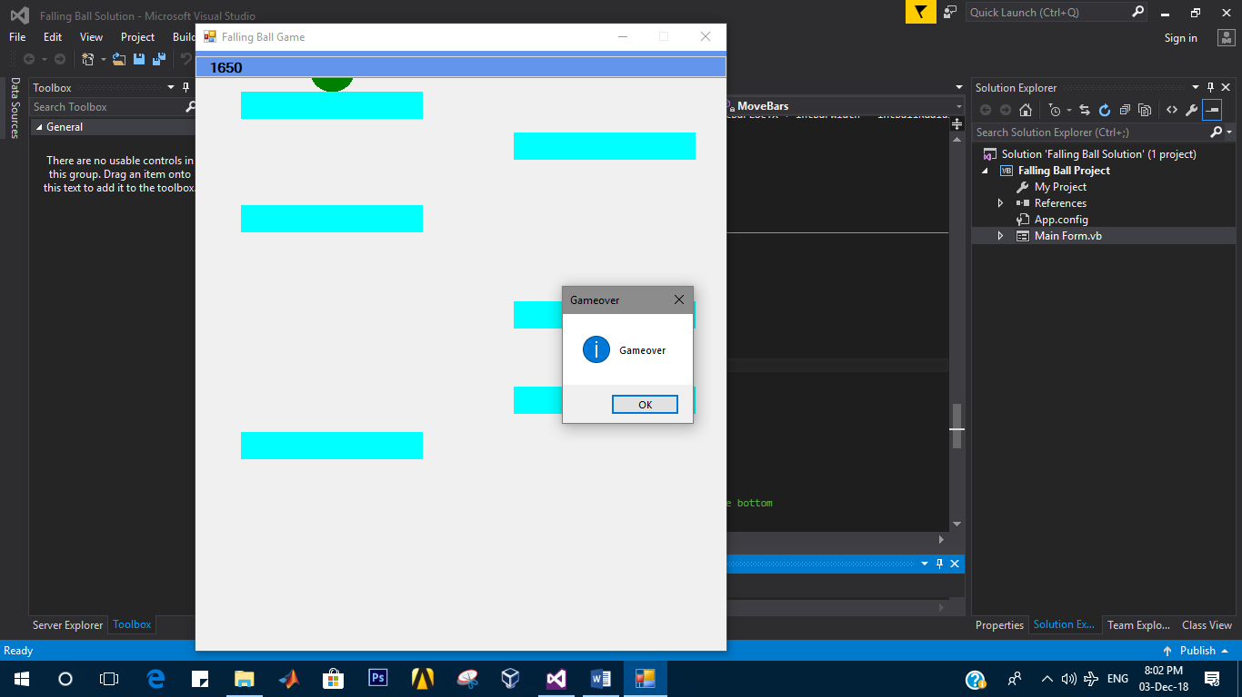

1. Hit the bottom of the screen with the ball and then click OK

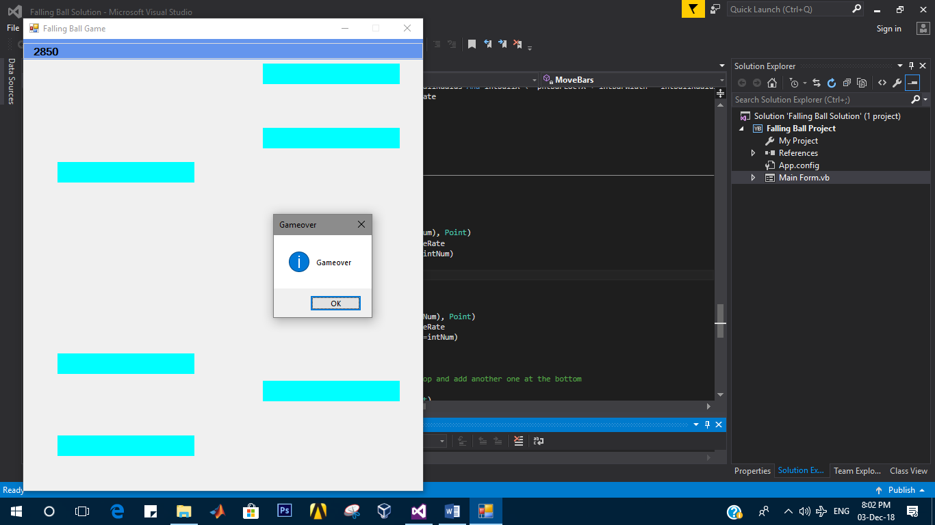

1. Press escape “X” icon at the top right corner of the screen